Name: Piotr Kawalec Class: Web Development 2  
Q1. Activity diagram, use case description  
  
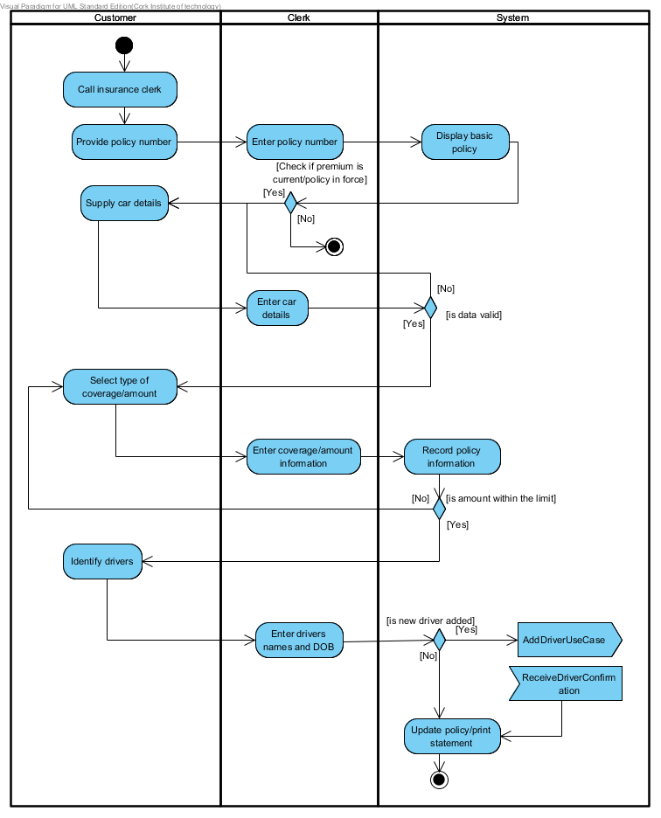

|  |  |  |
| --- | --- | --- |
| Use Case Name: | **Add new vehicle** | |
| Scenario: | Add new vehicle to an existing policy | |
| Triggering Event: | Need for new vehicle registration | |
| Brief Description: | A customer wants to add new car into existing policy. The clerk collects all information required, verifies it and updates the policy. Prints updated statement. | |
| Actors: | Clerk | |
| Stakeholders: | Clerk, accounting department | |
| Preconditions: | Customer must hold existing policy and premium is current. | |
| Postconditions: | New car added to the policy, new premium calculated, new policy statement printed | |
| Flow of Events: | Actor | System |
| 1. Clerk enters policy number  3. Clerk verifies displayed information and enters vehicle details  5. Clerk enters type of coverage and the amount  7. Clerk enters car drivers and percent of driving time for each | 2. System displays insurance policy  4. System validates information provided.  6. System records entered values and validates amount with policy limits  8. System records details, updates policy, calculates premium, prints policy statement |
| Exception Conditions: | 3. If premium is not paid system offers payment option before continue.  4. If any of vehicle detail is not valid system allows for making correction  6. If policy limits are exceeded system offers different coverage(goes back to 5.) or extension to the policy  7. If new driver is added system calls *Add new driver* use case before continue | |

Q2. Pre-, post- conditions

Preconditions: policy, InsuredPerson,

Postconditions: Vehicle has Coverages, Policy has InsuredVehicles, Policy has InsuredPersons, InsuredVehicle, InsuredPerson

Q3. System sequence diagram  
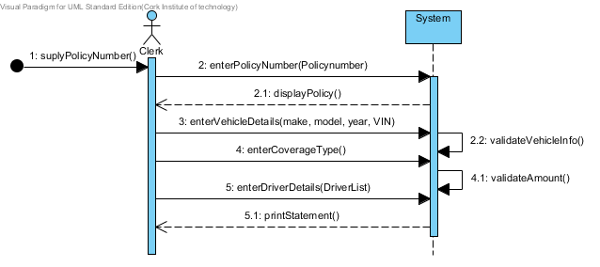  
  
Q4 Class diagram  
